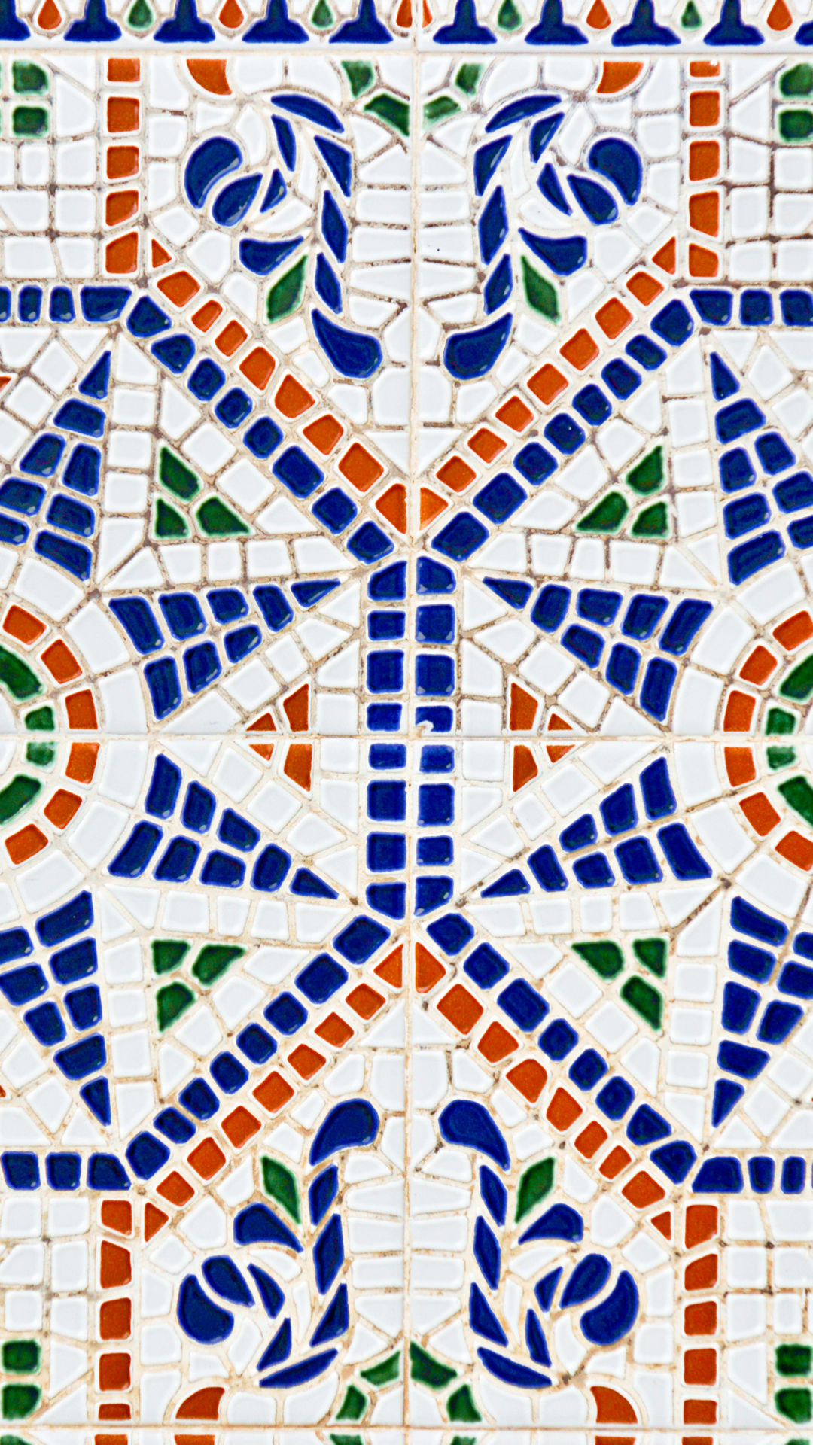
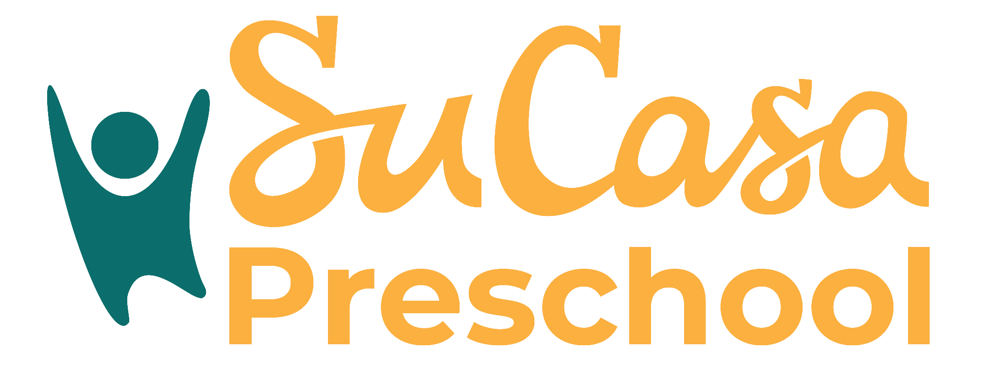

Parent
Handbook

This book explains how our preschool works. You’ll find information about our rules, daily schedule, and how we talk with parents. It helps you know what to expect each day.


Español English

